Homework 4 By Tiwalope Shadare
Based on the SQL script file for Pine Valley Furniture Company, write the SQL statements
for the following queries
Question 1. List all customers
Answer: SELECT * FROM S_CUSTOMER_T;
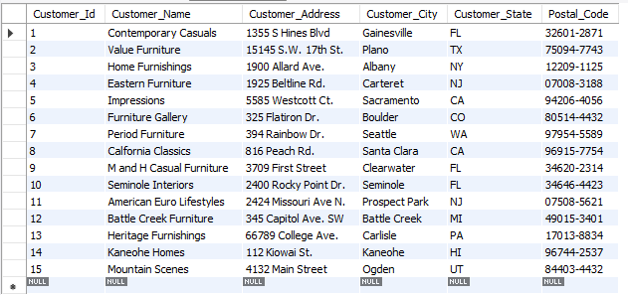

Question 2. What is the address of the customer named Home Furnishings? Use Alias, Name
for customer name.
Answer: SELECT CUSTOMER_ADDRESS, CUSTOMER_NAME AS NAME
FROM S_CUSTOMER_T
WHERE CUSTOMER_NAME = 'HOME FURNISHINGS';
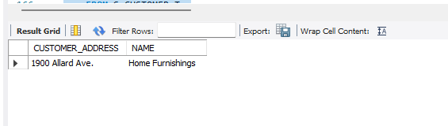

Question 3. Which Product has a standard price of less than $200?
Answer: SELECT* FROM S_PRODUCT_T
WHERE STANDARD_PRICE < 200;
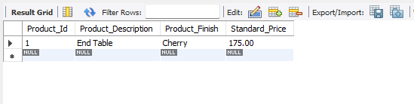
Question4. What is the average standard price of products?
Answer: SELECT AVG(STANDARD_PRICE) AS AVERAGE_STANDARD_PRICE
FROM S_PRODUCT_T;
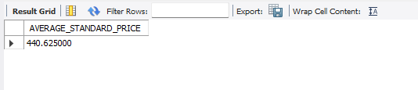
Question 5. What is the price of most expensive product in inventory?
Answer: SELECT MAX(STANDARD_PRICE) AS MOST_EXPENSIVE_PRICE
FROM S_PRODUCT_T;
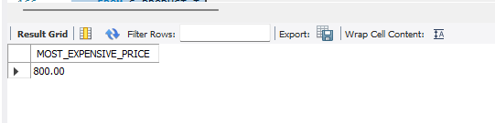
Question 6. Count all orders.
Answer: SELECT COUNT(*)
FROM S_ORDER_T;
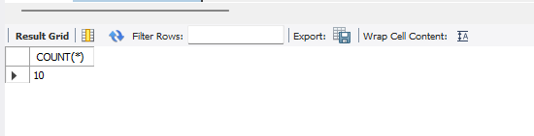
Question 7. How many different kinds of items were ordered on order number 1006?
Answer: SELECT COUNT(*)
FROM S_ORDER_LINE_T
WHERE ORDER_ID = 1006;
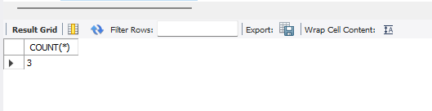

Question 8. Which order have been placed before 2020-10-24?
Answer: SELECT * FROM S_ORDER_T
WHERE ORDER_DATE < '2020-10-24';
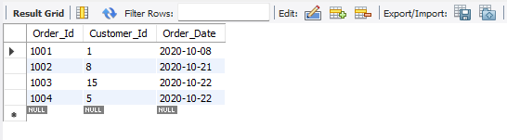

Question 9. Alphabetically, what is the last product name in the PRODUCT table? Use an alias NAME.
Answer: SELECT PRODUCT_DESCRIPTION AS NAME
FROM S_PRODUCT_T
ORDER BY PRODUCT_DESCRIPTION DESC
LIMIT 1;
